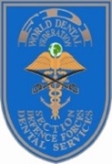


ABSTRACT FORM

Section Defense Forces Dental Services Annual Meeting 2026
Prague, Czech Republic 31 August - 03 September 2026

Kindly submit to sdfd.services@gmail.com no later than 01 May 2026
Register online at: https://forms.gle/VyWK3S1RDvpgGS7a8 no later than 01 May 2026

PRESENTATION TITLE
PRESENTER(S)
COUNTRY
ORGANISATION
ABSTRACT
BRIEF BIOGRAPHY OF PRESENTER (<100words)

Note: Each presentation duration is 15 minutes with additional 5 minutes allocated for Questions.

